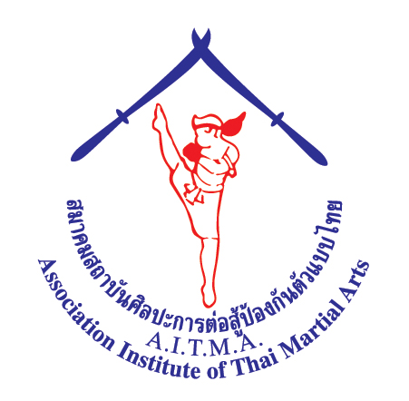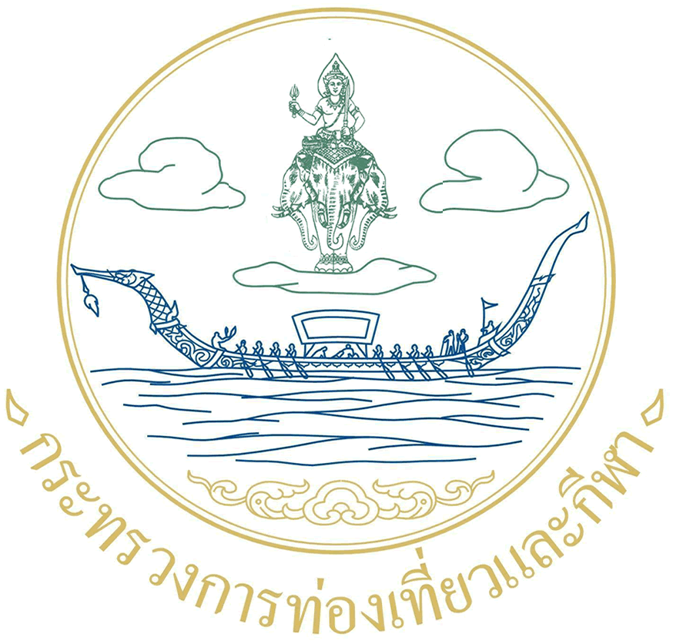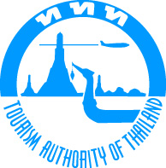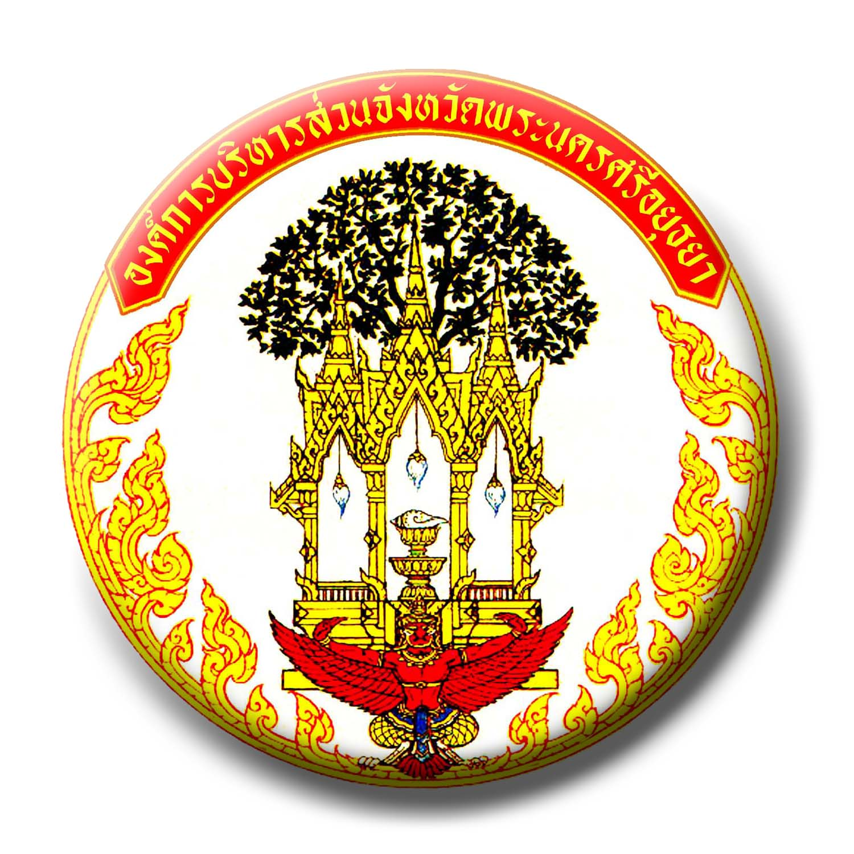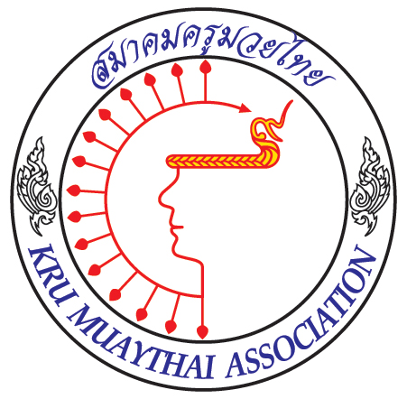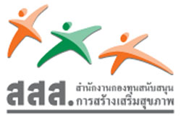

Ministry of Tourism and Sport City of Ayutthaya

5 ^{TH} World Thai Martial Arts Festival
CELEBRATION NAIKHANOM TOM DAY
ASSOCIATION INSTITUTE OF THAI MARTIAL ARTS
Wai-Kru Ceremony
Muay Boran & Krabi – Krabong Seminar
Nai Khanomtom Pro/Championships Belt

Date: 13th - 17th March 2009, Venue:
City of Ayutthaya Stadium, Ayutthaya, Thailand

AITMA, ASSOCIATION INSTITUTE OF THAI MARTIAL ARTS
NATIONAL STADIUM, RAMA 1 ROAD, BANGKOK 10330. Tel: (668) 13024622 Fax: (662)6124020

Official website: www.aitmathai.com;
www.thaimartialarts.org www.aitma.de

gmaster_woody@hotmail.com; president@aitma.de; info@aitma.de

1. Entries: - Entry Form A (Entry by Number) must reach to organizer by
January 10th 2009. PLEASE SEND ALL Entry Forms TO GM Woody
Gmaster_woody@hotmail.com
- Entry Form B (Entry by Name) and Flight and Hotel information
Form must reach to organizer by February 10th 2009.
- Country Entries are Unlimited up to a maximum of 10 per age group in each
Category.

2. Events & Activities

Open Championships & Competition will consist of the following

1) Wai Kru & Mae Mai Competition.
  - 2 per Team unlimited Teams per Country Male, Female or Mixed
  - Over 15 Years to Under 19 Years Male & Female
  - Over 19 Years Male & Female

2) Keta Muaythai, Aerobic Muaythai.

3.1 Over 15 years and less than 21 years age, Male and Female.
Over 21 years age, Male and Female

- Muay Kard Chiek

Demonstration, and Open Muay Boran Contest
Following the Ancient concept style of Muay Boran. Please look in
Muay Boran, fight rules & regulations

4) Nai Khanomtom Professional Championships Belts, Prizes, Certificate
This is a knockout Championships (so if you bring 2 athletes in the same categories
they may be matched into each other be aware of this.
All Weight categories as per Professional Rules, and will be 5 x 3 Mins Rounds
Any Country can send athletes to be matched in advance, please make sure the level of the athlete are A’ Class, this is for the safety of ALL athletes and this will be checked in advance, any athlete found to be sending incorrect information will be excluded.
Weigh Categories are: 54kg 57kg 60kg 63.5 kg 67kg 71kg up to heavy weight
Awards; Championships Belts, Certificate, Pocket Money.

- Celebration of Nai Khanomtom Day and Wai-Kru Muaythai
The day of pay respect, and homage to Nai Khanomtom, passed and present teachers, acknowledgement of, New comer teachers, by present certificate and higher rank of Mongkon.

6) Seminar of Muay Boran and Krabi-Krabong by top Grand Masters.

Date | Time | Activity
13th March 09 | 08:00 - | Final Arrival of ALL Teams & Participants
14th March 09 | 08:00 – | Registration for Courses at Hotel  Register for the  Muay Boran / Muay Kard Chiek and Athletes in Muaythai-Professional  Lunch Open Ceremony and Information for both Courses  Muay Boran & Krabi Krabong Courses
15th March 09 | 06.00 | FUN 10K RUN for all.  Muaythai  Official Meeting  Official Draw. (Hotel)  Separate of all sport and subject of competition  …………………………………………………………..  Muay Boran & Krabi Krabong , Aerobic Muaythai
16th March 09 |  | Muaythai  Official Meeting  Official Draw. (Hotel)  Separate of all sport and subject of competition  …………………………………………………………..  Muay Boran & Krabi Krabong , Aerobic Muaythai
17th March 09 | 06.00 -10.00  09.00 -12.00  12.00- 13.15  13.30- 15.30 | PAY HOMAGE TO NAI KHANOMTOM CEREMONY  WAI KRU ceremony start by arrival of the chairman  ALL THE ATHLETES AND OFFICIALS IN TRADITINAL UNIFORM  Introduction to all the Grand Masters and Masters all  Ranking of Kru. Oats of respect to all teachers.  Present Mongkon and blessing to the new comers.  All the participant entry and line up to countries and the  Fighter for Muay Boran and Professional ready for the start.  FAREWEL AND CLOSING SPEECH BY THE GOVERNOR OF AYUTTHAYA
18th March 09 | 07.00-08.30  10.00  13.30-18.00  18.30 | HAVE BREAKFAST AND CHECK OUT  TRAVEL BACK TO BANGKOK AND CHECK IN AT TWIN TOWER  All amateur register weight-in and report & Team Manager meeting  Welcome Party

* The Grand Master conducting the Traditional Muay Boran & Krabi Krabong Courses along with
Khan grading for students who register for them are: -

Grand Master Phosawat, Grand Master Yodthong, Grand Master Vichit Chechurn
Grand Master Woody, Grand Master Sanae Tubtimtong.

* The organizer has the right to modify the schedule depending on the number of entries.

6. Entries Fee: (3Day Course in Muay Boran & Krabi Krabong)

The courses fee required is $120 USD Per Adult and $70 USD Per Junior per event paid at the registration desk before starting, the Competition Fee is $20 for the Amateur Open Championships. The fee covers the cost of Transportation to & from the airport and includes the welcome party along with a participation certificate.

*Khan & Sash grading for students who register will be $20 each level.
*Kru Assessment & Register Khan 11 to 13 Fee $20 per student.
*All Traditional Uniform and Mongkon’s must be worn for Wai Kru Ceremony.

7. Rules and Regulation:
The Competition Rules and Regulations will run in accordance with the following organisations.
A.I.T.M.A

8. Accommodation:

Official Hotel | Room type | Room Rate
Woraburi Ayothaya  www.woraburi.com | Single (1 bed) | 1.500,-- Baht per Night
Woraburi Ayothaya  www.woraburi.com | Twin room (2 beds) | 1.750,-- Baht per Night

(Including breakfast, service charge, VATS, & Tax). Lunch 170 baht Dinner 200 baht extra

9. Prize:
9.1 Medal & Diploma will be Awarded to the 1st, 2nd, and 3rd places in each class.

10. Transportation Service:
Shuttle bus will be arranged from Bangkok international airport to the official hotel and from the official hotel to the venue only for the participating delegates who are staying at the official hotel.

Please inform us about your flight schedule (arrival date, time and flight number) and hotel reservation by

February 10th 2009.

11. VISA:
Please contact the Organizing committee regarding any VISA requirements or apply for VISA from your own Embassy, Consulate or VISA Office in your country.

12. Flags / Anthems:

Please bring audio – cassette tape or CD of your National Anthem, and two National flags
(72 cm. x 120 cm.).

A.I.T.M.A. 5 ^{TH} World Thai Martial Arts Festival 2009
Entry Form By Name Muaythai Senior (Form A)

Entry Form A (By Number)
Must reach to organizer Before Jan 10th 2009

Federation: _______________________________________________________
Address: _________________________________________________________
Tel _______________ Fax_______________ Email______________________

 | No. of  Officer | No. of Male  Referee | No. of Female  Referee | No. of  Male Athletes | No. of  Female Athletes

Wai Kru & Mae Mai

Keta Muay Thai

Aerobic Muay Thai

Muay Kard Chiek Competition
Total

Signature/Stamp: __________________________ Date: ________________

Please send entry by Number. Before 10th Feb 2009
http://www.aitmathai.com
More detail contact AITMA Vice President Grand Master Woody
E - Mail: gmaster_woody@hotmail.com Mobile: +66813024622

A.I.T.M.A. 5 ^{TH} World Thai Martial Arts Festival 2009
Entry Form By Name (Form B)
Must reach to organizer Before Feb 10th 2009

Federation: _______________________________________________________
Address: _________________________________________________________
Tel _______________ Fax_______________ Email______________________

Officials/Coaches  Name and Family Name | Referee/Judges  Name and Family Name

Mae Mai Senior
Weight Categories | Male Senior | Female Senior
Weight Categories | Name and Family Name | Name and Family Name

This Form must reach to organizer Before February 10th , 2009
Signature/Stamp: ______________________________ Date: ________________
( )

Please send entry by Number. Before 10th Feb 2009
http://www.aitmathai.com
More detail contact AITMA Vice President Grand Master Woody
E - Mail: gmaster_woody@hotmail.com Mobile: +66813024622

A.I.T.M.A. 5 ^{TH} World Thai Martial Arts Festival 2009
Entry Form By Name (Form B)
Must reach to organizer Before Feb 10th 2009

Federation: _______________________________________________________
Address: _________________________________________________________
Tel _______________ Fax_______________ Email______________________

Officials/Coaches  Name and Family Name | Referee/Judges  Name and Family Name

Keta MuayThai

Weight Categories | Male Youth | Female Youth
Weight Categories | Name and Family Name | Name and Family Name
This Form must reach to organizer Before February 10th , 2009
Signature/Stamp: ______________________________ Date: ________________
( )

Please send entry by Number. Before 10th Feb 2009
http://www.aitmathai.com
More detail contact AITMA Vice President Grand Master Woody
E - Mail: gmaster_woody@hotmail.com Mobile: +66813024622

A.I.T.M.A. 5 ^{TH} World Thai Martial Arts Festival 2009

Flight and Hotel Information Form
This Form must reach to organizer Before February 10th 2009

Country / Pays _________________________________________________________________

Head of Delegation / Chef de Delegation__________________________________________________

Tel ___________________ Fax_______________________ Email____________________________

8. Accommodation:

Official Hotel | Room type | Room Rate
 | Single (1 bed) | Baht per Night
 | Twin room (2 beds) | Baht per Night
 | Triple room | Baht per Night

Accommodation:
Check-In Date | Check-Out Date | Room type | No. of  Single Room | No. of  Double room | No. of  Triple room

Flight Schedule:

 | Date | Time | Flight | No. of Person
Arrival
Departure
Signature/Stamp: __________________________ Date: ________________
( )

Please send entry by Number. Before 10th Feb 2009
http://www.aitmathai.com
More detail contact AITMA Vice President Grand Master Woody
E - Mail: gmaster_woody@hotmail.com Mobile: +66813024622

